Log Search Module

Log Search Module Overview
The Log Search module is provided as a tool to search the Machine Control Logs for maintenance and diagnostic information. The software automatically selects a log file based on the current day of the month (the file names must be configured for day of month rollover).

The display is updated with each log entry found and is displayed in timestamp sequence.

Multiple log files may be combined and there respective entries are sorted and displayed in time base sequence.

Confidential/Proprietary Statement
This document contains trade secrets and information that is considered confidential and proprietary to Fortna, Inc. It may not be duplicated, used, or disclosed outside the original recipient organization, and it may not be duplicated, in whole or in part, for any purpose other than to evaluate this document. Fortna, Inc. reserves the right to modify this document as necessary to reflect any terms and conditions negotiated and included as part of a subsequent contract or purchase order.

Log Search Tools/Menus
The LogSearch Module is installed with 3 configuration and control files.

- Logs – Unix script, that verifies the Log Search function is not already running, and starts the module. The script can be included in the Batches Menu for startup from a Fortna Control Menu.

- LogSearch.config – Configuration file for the Log Search module. The file contains the parameters for the Log Search Module.

- LogSearch – Executeable module that runs and displays the log files. The module uses QNX GUI and cannot be run from character based, terminal window (such as modem interface).

If the Log Search Module is accessed from a Fortna Control node, the “Logs” entry must be added to the Fortna Project Menu and the “Logs” entry must be added to the Batches Configuration.

Log Search Display and Configuration Utility
The Log Search Module is configured using the Log Search Display Utility.

The Log Search Utility displays the currently selected SORT, CTRL and SERV log files.

The utility is interactive and each file may be selected or changed by clicking on the field.

If a file name is changed the module will automatically save the new file name in the Config file described above.

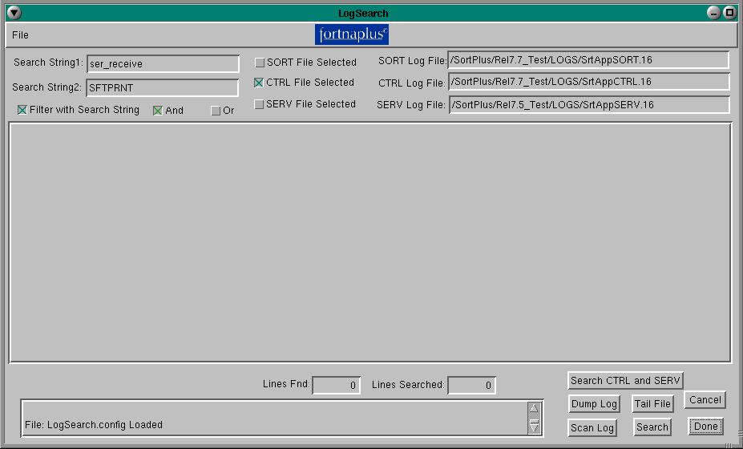

Log Search Check Box and Button Selections

The Log Search Module can be run by simply selecting a Button, such as “Scan Log” or “Dump Log”, or it may be run by selecting specific options and then selecting the “Search” or “Tail File” buttons.

Check Boxes:

- SORT File Selected – this check box indicates the SORT Log File will be used in the next “Search” or “Tail File” operation.
- CTRL File Selected - this check box indicates the CTRL Log File will be used in the next “Search” or “Tail File” operation.
- SERV File Selected - this check box indicates the SERV Log File will be used in the next “Search” or “Tail File” operation.
- Filter with Search String – this check box indicates that only log entries with the strings found in the data entry boxes, “Search String1” and “Search String 2” will be displayed.
- And – this check box indicates that the Filter search strings will be “Anded” together (both strings must be found in each line).
- Or – this check box indicates that the Filter search strings will be “Ored” together (one of the search strings must be found in each line).

Buttons:

- Search CTRL and SERV – this button will search the “CTRL” and “SERV” log files for log entries and the 2 files are combined in time sequence. If the “Filter with Search String” is selected then only log entries with these strings will be displayed.
- Dump Log – this button will search the “SORT” log for log entries that contain the “DUMP” search string. The “DUMP” entries are used in applications where multiple shifters are used to construct a sorter.
- Scan Log – this button will search the “CTRL” log for entries that contain the “ser_receive” or “SFTPRNT” search strings. A “ser_receive” search string is created when a serial message is received from a scanner. A “SFTPRNT” log entry is created whenever a scan event occurs. The log entry indicates where scan data is married to a container shifter image.
- Tail File – this button will tail the selected files and will display any log entries that match the “Search String” entered, if the “Filter with Search String” check box is selected.
- Search – this button will search the selected files and will display any log entries that match the “Search String” entered, if the “Filter with Search String” check box is selected.
- Cancel – this button will stop the search or tail in process, without clearing the log display.
- Done – this button will stop the search or tail in process and will exit from the Log Search Module.

